<Local Council Name>

originally published
<month, year>
to be reviewed annually

Declaration of a
Climate Emergency

Contents
1 Climate Emergency Statement 3
2 Community Engagement 4
2.1 The Great Collaboration 4
2.2 Communication 4
2.3 Monitoring 4
3 Community Carbon Calculating 5
3.1 Introduction 5
3.2 Methodology 5
3.3 <Local Council>-specific data 5
3.4 Annual Review 5
3.5 Recording our Starting Point 6
4 Accessing Support for our Actions 10

Climate Emergency Statement
<Local Council Name> believes that:
- All governments (national, regional and local) have a responsibility to limit the negative impacts of climate breakdown. This statement acknowledges that responsibility within <Local Council Name>.
- Local governments should not wait for national governments to change their policies, but act independently, and further, use this pledge to push local and national Government to act as part of this commitment.
- It is important for the residents of <Local Council Name> and the UK that councils commit to carbon neutrality as quickly as possible, and no later than 2050 in accordance with Committee for Climate Change recommendations. That begins with this statement.
- The consequences of global temperature rising above 1.5 degrees Celsius will be so severe that preventing this from happening must be our number one priority and thus built into our decision-making process and plans for the future.
- Climate action can deliver economic benefits in terms of jobs, financial savings and market opportunities (as well as improved well-being for people worldwide). Action now will certainly reduce long term cost and suffering.
<Local Council Name> agrees to:
- Work with local partners to produce a set of annual Carbon Reduction Actions covering all relevant council strategies. This report will detail the specific actions to be taken for the next year.
- Help provide the necessary resource to deliver our Carbon Reduction Actions.
- Produce a Carbon Reduction Impact Report for each year, showing progress against the Carbon Reduction Actions.
- Seek approval for the Carbon Reduction Actions and Carbon Reduction Impact Report at the Annual Meeting of <Local Council Name>.
- To promote and use The Great Collaboration (https://greatcollaboration.uk/) to engage with our local community; to inspire our community to take individual climate actions; to share best practice; to use the data on local actions provided by the website to inform council climate actions.

Community Engagement

The Great Collaboration
<Local Council Name> will use The Great Collaboration website (https://greatcollaboration.uk) as its primary tool for engaging the community in climate action.
The website contains over 60 beneficial climate actions, across 7 categories, and encourages individuals and businesses to commit to taking some of them.
<Local Council Name> will structure its own climate actions to support residents and businesses to achieve the actions defined within The Great Collaboration. In doing so, the actions of <Local Council Name> and those of residents and businesses will become aligned.
Our Climate Reduction Actions and Climate Action Impact Report will be structured around these categories and actions.

Communication
<Local Council Name> will actively and continuously promote the use of The Great Collaboration through all the communication media available to it, namely:
- <Newsletter>
- <Social media accounts>
- <Magazine>
- <Noticeboards>
- <Community events>
- <Other>
There is a marketing campaign being orchestrated centrally for The Great Collaboration, producing social media posts and other marketing assets.
<Local Council Name> will make use of the posts and content generated by that central campaign to reinforce its own communication, by re-posting and sharing appropriate content as it becomes available.

Monitoring
<Local Council Name> will monitor progress, and inform decision making, by including an agenda item on Carbon Reduction Actions at least once a year at <Local Council Name> meeting.
During that agenda item two points will be considered:
- Progress on the defined Carbon Reduction Actions
- Resident and business community actions taken - and requests for help – informed by a report generated from The Great Collaboration website.

Community Carbon Calculating

Introduction
Successful carbon reduction requires an understanding of our current carbon footprint, and monitoring improvements over time.
Our carbon footprint is "a measure of the impact human activities have on the environment in terms of the amount of greenhouse gases produced, measured in units of carbon dioxide”.
Initially, we will use the IMPACT Community Carbon Calculator (https://impact-tool.org.uk) which provides parish-level analysis. It is produced by the Centre for Sustainable Energy with backing from the Department for Business, Energy & Industrial Strategy and others.

Methodology
IMPACT uses detailed calculations carried out by researchers at the Centre for Sustainable Energy and the University of Exeter's Centre for Energy and the Environment.
Two different types of footprint are presented in the tool: territorial and consumption-based. Each is a different method of accounting for the emissions generated within a geographical area.
Territorial and consumption-based footprints are complementary methods, rather than being directly comparable to each other, and both provide useful information to help target local action to reduce carbon emissions. A territorial carbon footprint includes all emissions that are generated within a defined geographical area, including those from industry, agriculture and transport activities. A consumption-based footprint includes upstream and downstream emissions from residents’ consumption of manufactured goods, food and their own transport activity, regardless of where the emissions occur.
For an in-depth explanation of the emissions figures present, a methodology paper is available here.
Whilst we recognise that there are different approaches for assessing a carbon footprint, and certain limitations, we believe that IMPACT provides a credible assessment at parish level and forms a worthwhile starting point.

<Local Council>-specific data
The IMPACT tool with data specific to <Local Council> can be found here <insert link to local council-specific page>.

Annual Review
IMPACT expects to update the underlying data at least once a year, subject to funding being available.
It is expected that more Community Carbon Calculators will emerge in the future, and methodologies will develop.
Annually, we will review the calculators available and we may change the tool we are using if a more appropriate one becomes available.

Recording our Starting Point
The following images are provided courtesy of the IMPACT tool, as at <date>. They provide a useful baseline as we embark on our journey to a net zero carbon future.
<Replace all the images below with versions for your local council>
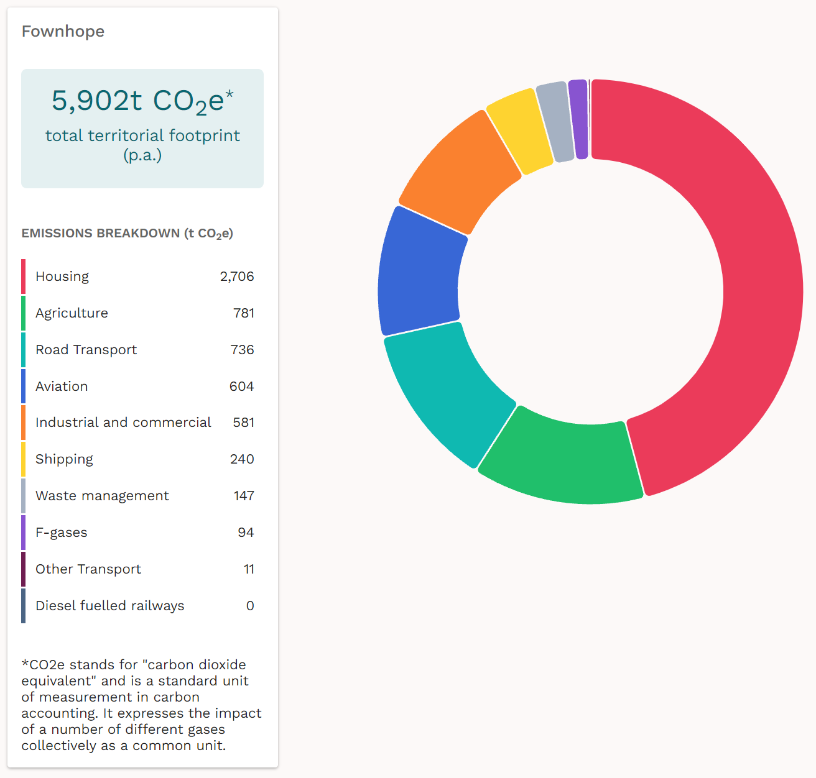

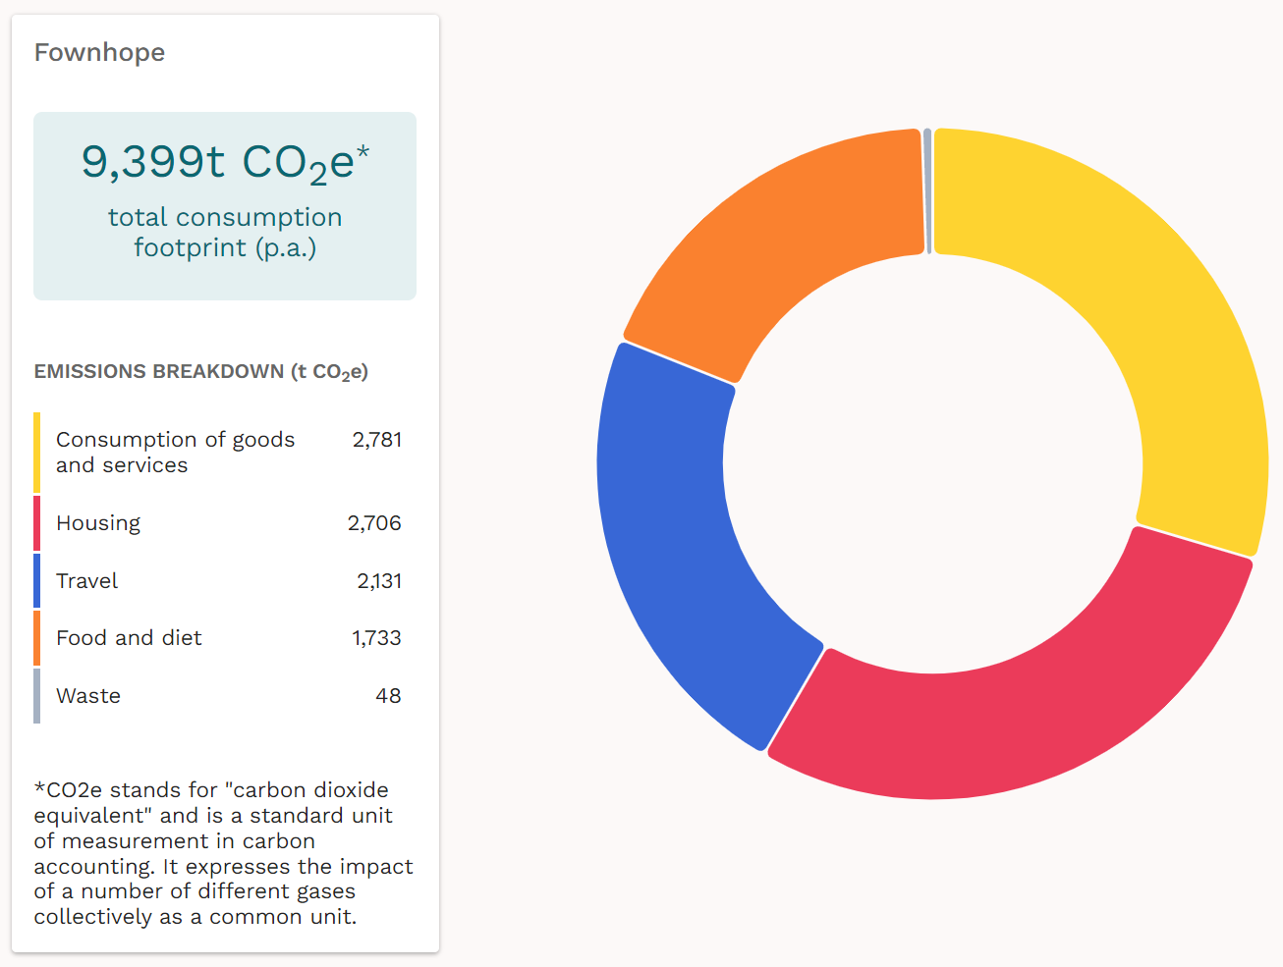

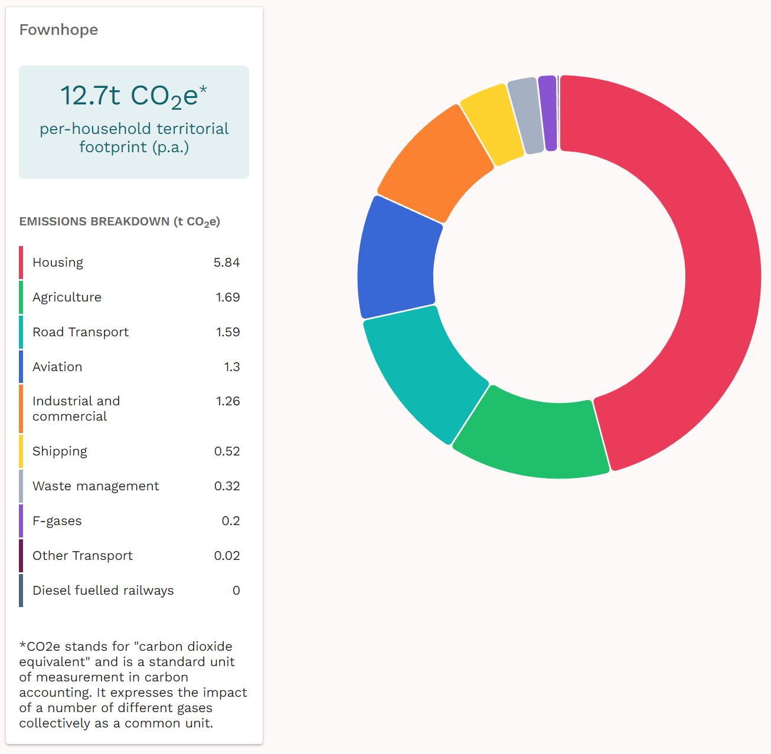

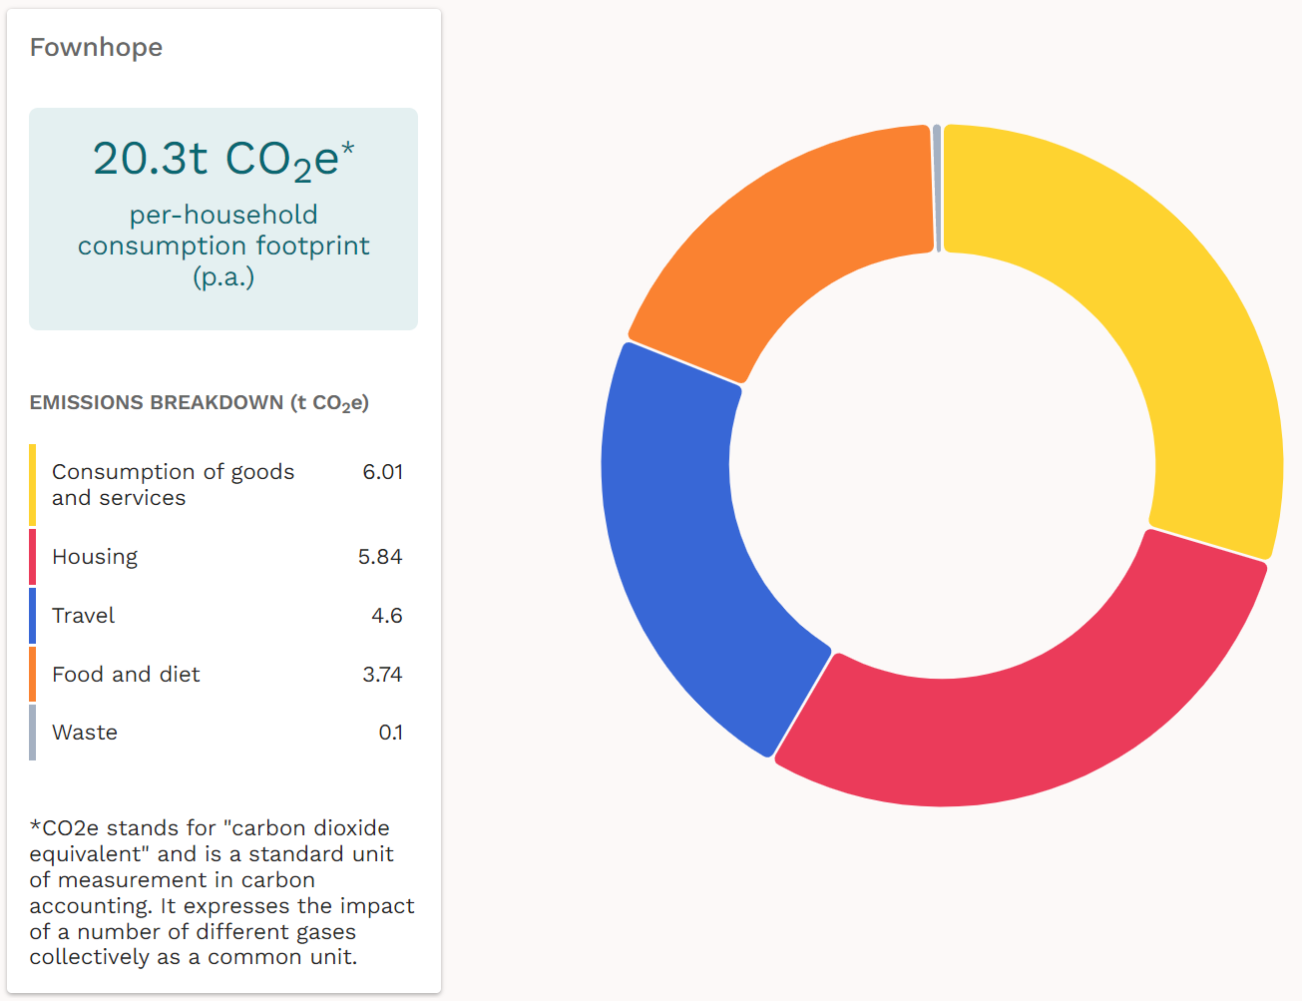

Accessing Support for our Actions
Local support for the actions we need to take can be found through Herefordshire Green Network (HGN), a local alliance of more than 80 Herefordshire based groups, organisations and businesses who work collaboratively to share best practice and support each other’s environmental action.
There are many other sources available now which will evolve over time. We need to be positively open to these to succeed in this declaration.

Signed and agreed by:

Cllr <Councillor Name>
Chair, on behalf of <Local Council>

Date:

